**CL Tutorial 3**

**Exercise 1**

* **Diligent and ignorant students**

$$\frac{a ⊧ b c ⊧¬b }{a ⊭ ¬c}$$

a is diligent students, b is successful, c is ignorant students

The syllogism is not sound, a counterexample is shown below:

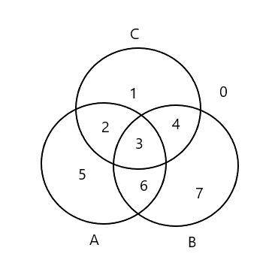

All a is b means 2 & 5 are empty.

No c is b means 3 & 4 are empty.

If some a is c, at least one of 2 and 3 is inhabited, but both 2 and 3 and empty from the predicate. Thus, the syllogism is not sound.

* **Eagle and pig**

$$\frac{a ⊧ c b ⊭c }{b ⊭a}$$

a is eagle, b is pig, c is fly

The syllogism is sound, as shown below:



All a is c, some b is not c, some c is not a.

All a is c means 5 & 6 are empty.

Some b is not c means at least one of 6 and 7 is inhabited – since 6 is empty, 7 is inhabited.

This shows that the conclusion is valid since,

Some b is not a means at least one of 1 and 4 is inhabited.

The syllogism is derived from Barbara:

$$\frac{a ⊧ b b ⊧ c }{a ⊧ c}$$

$$\frac{b ⊧ a a ⊧ c }{b ⊧ c}$$

$$\frac{b ⊭ c a ⊧c }{b ⊭a}$$

**Exercise 2**

There can only be exactly 2 occurrences of $⊭$ and/or $¬$ in any syllogisms.

$$\frac{a ⊧¬u u ⊧ h }{h ⊭ a}$$

Since this syllogism has only 1 $⊭$ and 1 $¬$, it is not sound.

**Exercise 3**

$$a ⊭¬a$$

null [x | x <- filter a xs, a x == True] == False



$$\frac{a ⊧ b c ⊧ a }{c ⊭¬b}$$

All a is b means 2 & 5 are empty.

All c is a means 2 & 1 & 4 are empty. (c only inhabits 3)

Thus, the syllogism is sound since some c is b means at least one of 3 and 4 is inhabited, which is true.

$$\frac{a ⊧ b c ⊭¬a }{c ⊭¬b} (Darii)$$ Since:

$$a ⊭¬a and c ⊭¬a$$

Thus, the syllogism is sound given $a ⊭¬a$ is true:

$$\frac{a ⊧ b c ⊧ a }{c ⊭¬b}$$

**Exercise 4**

1. and [hasThickBorder x | x <- things, isBig x && isAmber x] == False
2. or [isDisc x | x <- things, isSmall x]
3. or [ isAmber x | x <- things, isSmall x && isSquare x ]

**Exercise 6**

2, 3, 5, 6 are True.

**Exercise 7**

Yes, the property still holds for three predicates.